**Aliyaqara Estatika**

**1127050008**

**IF – G**

* State diagram vending machine

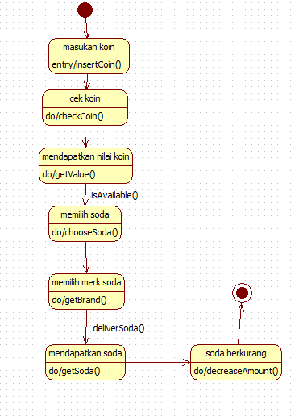

* Activity diagram vending machine

